**Business Intelligence Assignment-Bobble.ai**

1. **With Jio coming in, we have seen an influx of internet users from Tier 2 and Tier 3. Video/Content apps like YouTube and Tiktok have seen a huge growth while Amazon/Flipkart have not seen similar. What could be the reason for it? Feel free to use any publicly available data to support your hypotheses**

Jio was a blessing for the internet and the below graph is a proof for the same. In the year 2014 there was a total of 91,338,000* users and by 2016 there was 374,328,200* and now India is the country with second largest Internet user base.

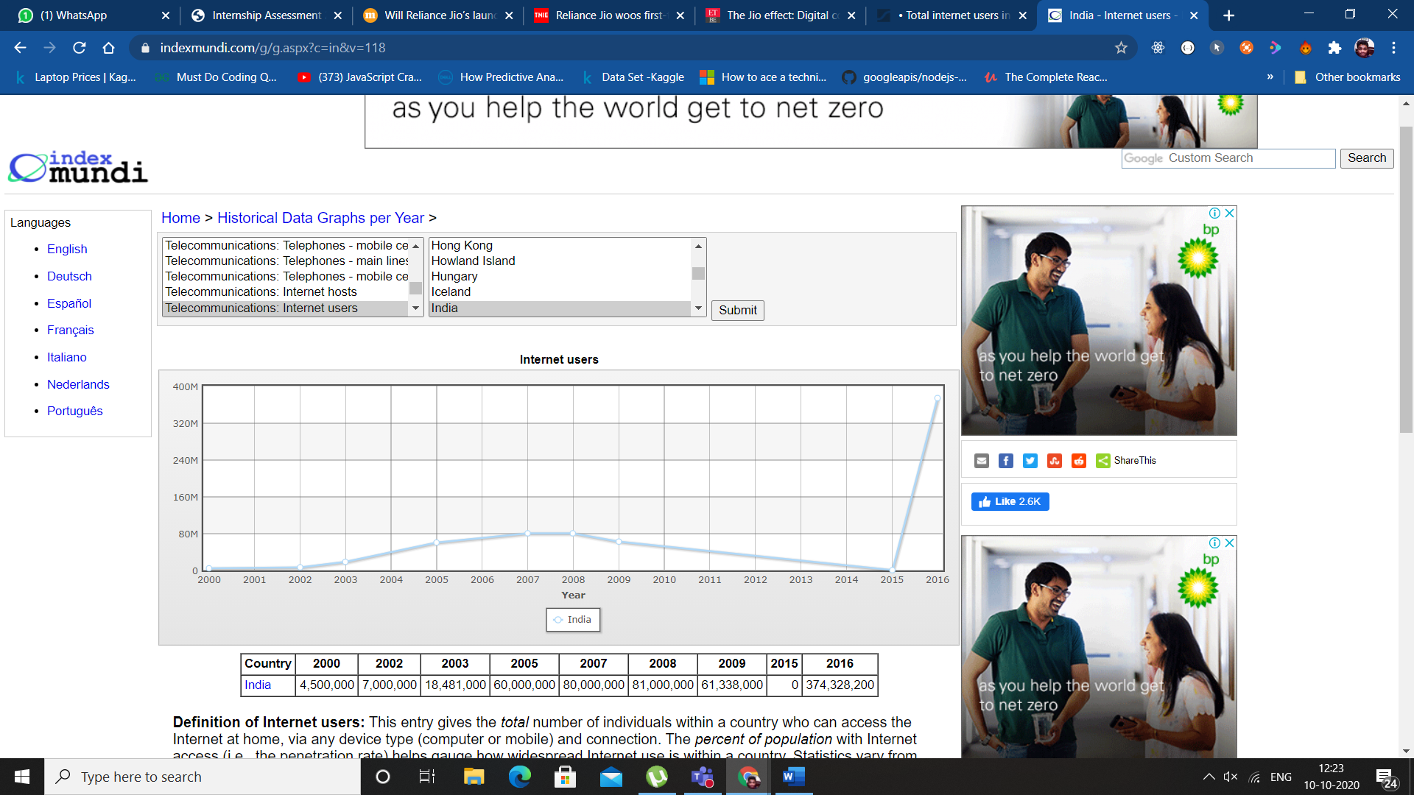This proves that JIO had century-defining effect on the Indian Internet.

To understand and give a better angle to the hypothesis on why JIO did not help ecommerce websites as it helped the Video/content apps one has to consider a lot of factors namely

* Age group of the users.
* Penetration of internet services.
* The economy during that time etc

For Video and Content apps the major source of income is advertisements though some platform has a premium section the major source of income remains the advertisements for various companies and the data and sentiment of its users are actually the product of the company and that’s what it sells to the companies which advertises in their application.

On the other hand, in Ecommerce this is not the case. The User itself is the customer and they need to buy.

The 62% of the internet users are between the age group of 9-18 and 50+.These age group either are not interested in ecommerce because they like the traditional way or don’t have the financial ability to buy goods from ecommerce sites on there own. But these 62%(mainly age group 13-18) internet users contribute heavily to the content and video applications. In fact 95% of the content makers and followers from TikTok were of teen age group. Hence they were a huge reason for the boom of content and video applications industry.

**2) New Onboarding Design at Nymtra.**

**Nymtra is India’s leading fashion app. The Product team revamped the app’s Onboarding**

**Flow on 31st July that introduced the following features:**

**● New walkthrough with 3 screens highlighting - extensive catalogue, free**

**shipping for the**

**first-order, and easy returns**

**● Added a ‘Skip Login’ option to the login screen at the end of the walkthrough**

**● Added a new “10,000+ items under** ₹**999” banner on the home screen.**

**You are attending the product review meeting on 5th November where the team looks at**

**the following data:**

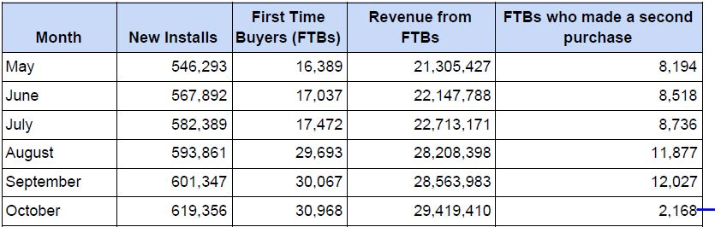

**Question: Is the onboarding flow revamp a success? Justify.**

Nymtra Product Team’s initiative to revamp the onboarding flow was a good plan on paper, now before making any statement regarding it’s success or failure in the market, let’s jump onto some graphs which have been derived from the tabular data of Nmyntra’s performance:

|  |  |  |
| --- | --- | --- |
| Month |  | Increase in new installs |
| May-Jun |  | 21,599 |
| Jun-Jul |  | 14497 |
| Jul-Aug |  | 11472 |
| Aug-Sep |  | 7486 |
| Sep-Oct |  | 18009 |

|  |  |  |
| --- | --- | --- |
| Month |  | Increase in FTBs |
| May-Jun |  | 648 |
| Jun-Jul |  | 435 |
| Jul-Aug |  | 12221 |
| Aug-Sep |  | 374 |
| Sep-Oct |  | 901 |

|  |  |  |
| --- | --- | --- |
| Month |  | Increase in Revenue  from FTBs |
| May-Jun |  | 842361 |
| Jun-Jul |  | 565383 |
| Jul-Aug |  | 5495227 |
| Aug-Sep |  | 355585 |
| Sep-Oct |  | 855427 |

|  |  |  |
| --- | --- | --- |
| Month |  | Increase in FTBs  Who made a second purchase |
| May-Jun |  | 324 |
| Jun-Jul |  | 218 |
| Jul-Aug |  | 3141 |
| Aug-Sep |  | 150 |
| Sep-Oct |  | -9859 |

As the numbers here show while the new installs are still increasing linearly but number of First Time Buyers (FTB) have increased with a bigger margin. Which has resulted generating better revenues from FTBs. We can argue on why the numbers of FTBs making second purchase decreased in the month of October because it maybe a result of multiple external and internal factors. The main motive of this revamp was to increase FTBs which has been achieved.

They have successfully eased their shopping experience by adding ‘Skip Login’ option and they have also efficiently highlighted their selling points on walkthrough.

1. **Personalised Recommendations at FilmiStar**

**Part A:**

**FilmiStar is India’s #1 app for watching movies. The Product team was tasked with**

**designing a new carousel on the home screen that will show personalised movie**

**recommendations based on the user’s taste. Currently, the home screen shows trending**

**and new movies only.**

**Questions:**

**1) What will be the change in user behavior once this feature is introduced?**

Customers love that personal touch, whether it’s being addressed by name in an email, a shop owner remembering their birthday, or being able to customize a website to their needs. So once this feature is introduced, it can make the customers feel like they’re our single most important user. Resulting in increased engagement of previous loyal users, who would also be spreading their own experiences of our new feature through word of mouth marketing as well. Also it would be candy for those audience too, who are new to these streaming applications and don't know much about how to find content in respect to their taste.

**2) What should be the goals and metrics for this feature?**

The goals and metrics for this feature should be to collect both types of data from the users:

<a> Explicit Data - Explicit data is what a user might tell, for example, if a user were to rate the series Stranger Things with a “thumbs up”, the feature would gain a clear understanding that this is the sort of content type the user enjoys and that they would want to have similar recommendations.

<b> Implicit Data - Implicit data, on the other hand, refers to data gathered and learned through a user’s behaviour. For example, if a user watches several series of Game of the Thrones, our feature should recommend similar content due to the users’ viewing behaviour, assuming that this is the sort of content the user enjoys.

And all these data would be used to increase the recommendation accuracy of out feature leading to an expected increase in the conversion rate for the subscription.

**3) How should this feature be launched and evaluated?**

This feature should be launced with a strong marketing campaign giving emphasis on the gaol of this feature, which would be, "To build deeper relationships with the customer". Along with a promise for best user friendly experience.

We can evaluate this feature by comparing numbers of subscription cancelled and number of subscriptions retained before and after its introduction, along with the data grasped from the volume of audience clicking on our recommendtions, and for how long they are viewing the recommended content.